**1.** Create three variables in a single line and assign values to them in such a manner that each one of

them belongs to a different data type.

**E.g. :**

**a = 1,**

**b = 2.01,**

**c = 'string'**

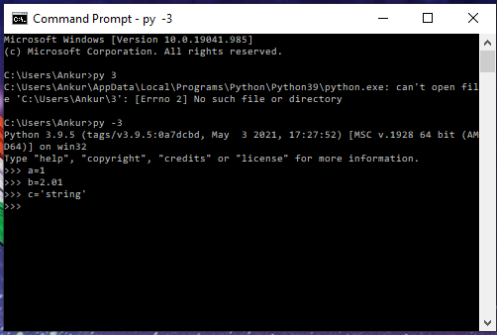

**2.** Create a variable of type complex and swap it with another variable of type integer.

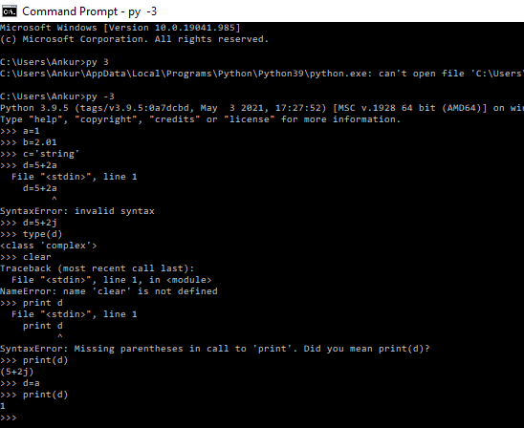

**3.** Swap two numbers using a third variable and do the same task without using any third variable.

>>> temp=a

>>> a=b

>>> b=temp

---------------------------------

>>> a=b

>>> b=a

>>>

**4.** Write a program that takes input from the user and prints it using both Python 2.x and Python 3.x

Version.

>>> e=input("Enter the number:")

Enter the number:5

>>> print(e)

5

>>>

**5.** Write a program to complete the task given below:

Ask users to enter any 2 numbers in between 1-10 , add the two numbers and keep the sum in

another variable called z. Add 30 to z and store the output in variable result and print result as the

final output.

for i in range(0,10):

    a = int(input("Enter first number:"))

    b = int(input("Enter second number:"))

    z = a+b

    sum = z +30

    print("Total + 30:",sum)

else:

    print("Please enter valid number from 1 to 10.")

**6.** Write a program to check the data type of the entered values.

a = input("Enter the value: ")

if(isinstance(a, float)):

    print "Entered value is float."

elif(isinstance(a, int)):

    print "Entered value is integer."

elif(isinstance(a,long)):

    print "Entered value is long."

elif(isinstance(a,str)):

    print "Entered value is string."

else:

    print "Unknow data type"

HINT: Printed output should say - The data type of the input value is : int/float/string/etc

**7.** Create Variables using formats such as Upper CamelCase, Lower CamelCase, SnakeCase and

UPPERCASE.

(Refer: https://capitalizemytitle.com/camel-case/)

**8.** If one data type value is assigned to ‘a’ variable and then a different data type value is assigned to ‘a’

again. Will it change the value? If Yes then Why?

**Yes it will change the value. It will print the current value for a variable.**